Student’s Name: Abdulrahman Almutairi

Professor: Mike Soltys

Course: GEEN 1400.S22

Date: 5/1/2022

Design Report

**Abstract**

         There is often the problem of hitting the mailbox when exiting the driveway or scraping the car against the blind spot in the garage. This project seeks to offer a solution to this problem by presenting a Prevent-A-Dent system, which is a smart home system that offers a solution for the home owners who are worried about damaging their cars or any other property. The system is designed in a manner that it actively alerts drivers and informs them how close they are to some point.

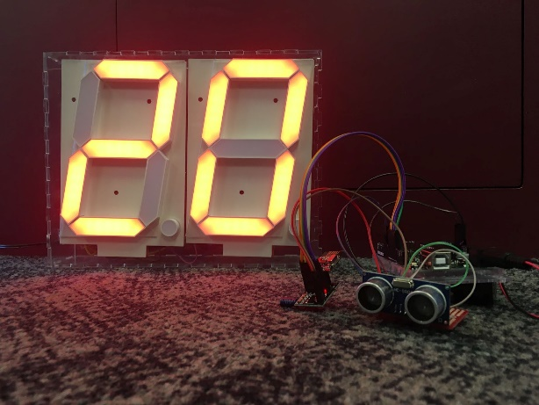

**Background**

         The project seeks to solve the problem of hitting the mailbox or scraping the car against a blind spot in the garage. The audience here is the drivers who are worried about damaging their cars by hitting them against blind spots. The system uses ultrasonic sensors to help in reading how far away the car is from the receiver.

**Design Requirements**

         Some of the design requirements include the CAD model of sensor box, which should be adjustable to make the sensor to be angled in any necessary direction. Not only that, but also we programmed the sensor to detect movement within 30 inches. The display should be easy to read from 100 inches away. Other key design components include:

Spark fun Reboard/Arduino Uno ($42)

Arduino HC-SR04 Ultrasonic sensor ($2)

Arduino NRF24L01 Bluetooth Radios ($3)

7-Segment Displays ($40)

Other assorted components ($8)

**Overview of Design Process**

* The design involves a digital display box that is laser cut out of acrylic and glued together with epoxy.  The system is designed to protect the inner electronics, which requires a nearby outlet to power the display. We made sure to develop the two circuits to match our design requirements.
* There are two supporting codes to make sure everything runs smoothly in this project. The first one is the transmitting radio code, which consists of the distance utilization of the ultrasound sensor, and the connection of the NRF24L01 transmitting radio. The second one is the receiving radio code, which contains the code of 2 seven segment displays in order to demonstrate the distance measurement in inches. As well as radio configuration to stabilize the connection.
* The technical problems I faced with coding the receiving radio was planning the flow of the code. In terms of circuitry, I faced the utmost challenge, which was sketching the circuits. Not only that, but also my contribution in this project was mainly in sketching the circuits, and applying my own knowledge in circuitry and soldering helped us save time and effort. As well as, coding the continuous display, which is a big part of our project.

**Testing**

         To determine if the project has attained the design requirements, the display should be bright and easy-to-read. The Bluetooth radios also need to operate consistently without any issues. Besides, the design used electrical tapes to secure the electronics and prevent wires from coming unplugged.

**Conclusion**

         This is a good project because it seeks to provide a solution for the homeowners that are concerned about the possibility of damaging their cars by hitting them against blind spots. It utilizes ultrasonic sensors to help in reading how far away a car is from the receiver. The system has the main hub that receives radio data, and transfers the distance determined by the sensor up towards the digital display.

**Appendices**

* The budget varies between $140-$160.
* The bill of materials ranges between $120-$140.
* Timeline: Finished look Mar.3- Hardware Bazaar Mar.11- Finished product Apr.17- Finished report Apr.22- Design EXPO Apr.23

In the shared link you will find all the supporting documents.

[**ABAlm/Prevent-A-Dent-Project (github.com)**](https://github.com/ABAlm/Prevent-A-Dent-Project)